EXPERIMENT 13: Fibonacci sequence
using module

A]ALGORITHM:
Step1: Start
Step 2: Create Module (fibonacci_module.py):
- Define a function generate_fibonacci_sequence(max_value)
- If max_value < 0, return empty list
- Initialize:
  - a = 0
  - b = 1
  - seq = []
- Repeat while a ≤ max_value:
- Add a to seq
- Update values: a = b
b = a + b (use proper swapping: a, b = b, a + b) e. Return seq
Step 3: Main Program (main.py):
- Import the module fibonacci_module
- Read integer input n
- Check if n > 0:
  - If true:
    - Call function generate_fibonacci_sequence(n) o Store result in fib_series
    - Print all elements of fib_series separated by space
  - If false: o Print "Please enter a positive integer"
Step 4: End

B]FLOWCHART:
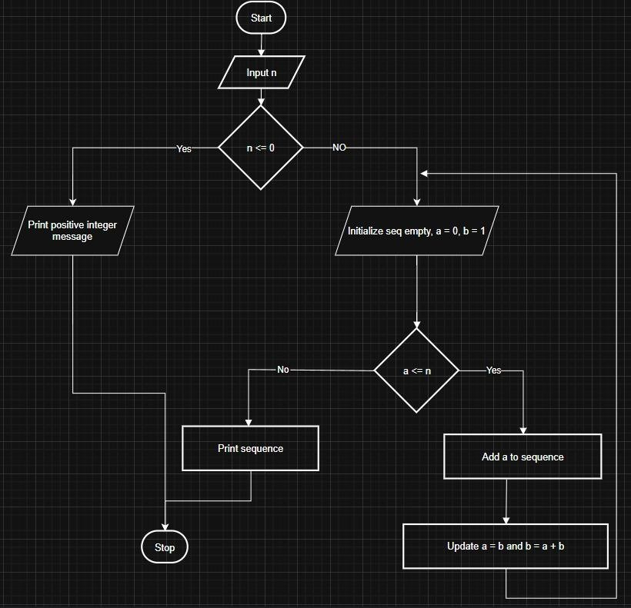

C] CODETANTRA:
